Bài 13

Dương Chí Khang – 1822040036

Tài Khoản:

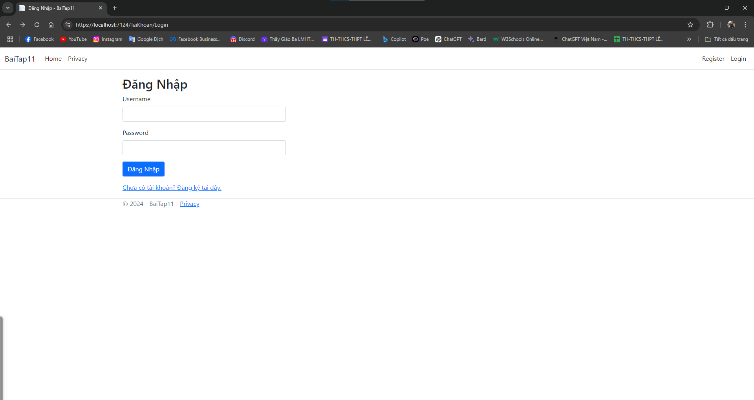

@{

ViewData["Title"] = "Đăng Nhập";

}

@model DangNhap

<div class="container-fluid p-0">

<div class="row">

<div class="col-md-4">

<h2 class="text-left">Đăng Nhập</h2>

<**form** **asp-action**="Login" method="post" class="form-group">

<div class="mb-3">

<**label** **asp-for**="Username" class="form-label"></**label**>

<**input** **asp-for**="Username" class="form-control" />

<**span** **asp-validation-for**="Username" class="text-danger"></**span**>

</div>

<div class="mb-3">

<**label** **asp-for**="Password" class="form-label"></**label**>

<**input** **asp-for**="Password" class="form-control" **type**="password" />

<**span** **asp-validation-for**="Password" class="text-danger"></**span**>

</div>

<button type="submit" class="btn btn-primary">Đăng Nhập</button>

</**form**>

<div class="mt-3">

<a href="@Url.Action("DangKy", "TaiKhoan")">Chưa có tài khoản? Đăng ký tại đây.</a>

</div>

</div>

</div>

</div>

@section Scripts {

@{

await Html.RenderPartialAsync("_ValidationScriptsPartial");

}

}

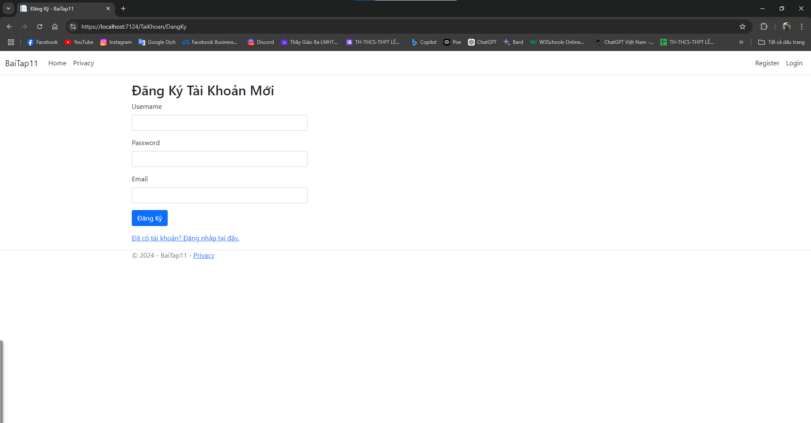

@{

ViewData["Title"] = "Đăng Ký";

}

@model BaiTap11.Models.TaiKhoan

<div class="container-fluid p-0">

<div class="row">

<div class="col-md-4">

<h2 class="text-left">Đăng Ký Tài Khoản Mới</h2>

<**form** **asp-action**="Register" method="post" class="form-group">

<div class="mb-3">

<**label** **asp-for**="Username" class="form-label"></**label**>

<**input** **asp-for**="Username" class="form-control" />

<**span** **asp-validation-for**="Username" class="text-danger"></**span**>

</div>

<div class="mb-3">

<**label** **asp-for**="Password" class="form-label"></**label**>

<**input** **asp-for**="Password" class="form-control" **type**="password" />

<**span** **asp-validation-for**="Password" class="text-danger"></**span**>

</div>

<div class="mb-3">

<**label** **asp-for**="Email" class="form-label"></**label**>

<**input** **asp-for**="Email" class="form-control" />

<**span** **asp-validation-for**="Email" class="text-danger"></**span**>

</div>

<button type="submit" class="btn btn-primary">Đăng Ký</button>

</**form**>

<div class="mt-3">

<a href="@Url.Action("Login", "TaiKhoan")">Đã có tài khoản? Đăng nhập tại đây.</a>

</div>

</div>

</div>

</div>

@section Scripts {

@{

await Html.RenderPartialAsync("_ValidationScriptsPartial");

}

}

Tài khoản controller

using BaiTap11.Data;

using BaiTap11.Models;

using Microsoft.AspNetCore.Mvc;

namespace BaiTap11.Controllers

{

public class TaiKhoanController : Controller

{

private readonly ApplicationDbContext _db;

public TaiKhoanController(ApplicationDbContext db)

{

_db = db;

}

[HttpGet]

public IActionResult DangKy()

{

return View();

}

[HttpPost]

public IActionResult DangKy(TaiKhoan taiKhoan)

{

if (ModelState.IsValid)

{

_db.TaiKhoan.Add(taiKhoan);

int result = _db.SaveChanges();

if (result > 0)

{

return RedirectToAction("Login", "TaiKhoan");

}

else

{

ModelState.AddModelError(string.Empty, "Đăng ký không thành công.");

}

}

return View(taiKhoan);

}

[HttpGet]

public IActionResult Login()

{

return View();

}

[HttpPost]

public IActionResult Login(TaiKhoan dangnhap)

{

if (ModelState.IsValid)

{

// Kiểm tra thông tin đăng nhập

TaiKhoan user = _db.TaiKhoan.FirstOrDefault(u => u.Username == dangnhap.Username && u.Password == dangnhap.Password);

if (user != null)

{

HttpContext.Session.SetString("Username", user.Username);

return RedirectToAction("Index", "Home");

}

else

{

ModelState.AddModelError(string.Empty, "Tên đăng nhập hoặc mật khẩu không đúng.");

}

}

return View(dangnhap);

}

}

}

Class TaiKhoan

using System.ComponentModel.DataAnnotations;

namespace BaiTap11.Models

{

public class TaiKhoan

{

public int Id { get; set; }

[Required(ErrorMessage = "Username is required.")]

public string Username { get; set; }

[Required(ErrorMessage = "Password is required.")]

[MinLength(6, ErrorMessage = "Password must be at least 6 characters long.")]

public string Password { get; set; }

[Required(ErrorMessage = "Email is required.")]

[EmailAddress(ErrorMessage = "Invalid email format.")]

public string Email { get; set; }

public DateTime DateCreated { get; set; } = DateTime.Now;

public bool IsActive { get; set; } = true;

}

}

Class DangNhap

using System.ComponentModel.DataAnnotations;

namespace BaiTap11.Models

{

public class DangNhap

{

[Required(ErrorMessage = "Username is required.")]

public string Username { get; set; }

[Required(ErrorMessage = "Password is required.")]

public string Password { get; set; }

}

}

Thể Loại:

TheLoai Controller:

using BaiTap11.Data;

using BaiTap11.Models;

using Microsoft.AspNetCore.Mvc;

namespace BaiTap11.Controllers

{

public class TheLoaiController : Controller

{

private readonly ApplicationDbContext _db;

public TheLoaiController(ApplicationDbContext db)

{

_db = db;

}

public IActionResult Index()

{

var theloai = _db.TheLoai.ToList();

ViewBag.TheLoai = theloai;

return View();

}

[HttpGet]

public IActionResult Create()

{

return View();

}

[HttpPost]

public IActionResult Create(TheLoai theloai)

{

if (ModelState.IsValid)

{

_db.TheLoai.Add(theloai);

_db.SaveChanges();

return RedirectToAction("Index");

}

return View(theloai);

}

[HttpGet]

public IActionResult Edit(int id)

{

if (id == 0)

{

return NotFound();

}

var theloai = _db.TheLoai.Find(id);

if (theloai == null)

{

return NotFound();

}

return View(theloai);

}

[HttpPost]

public IActionResult Edit(TheLoai theloai)

{

if (ModelState.IsValid)

{

try

{

_db.TheLoai.Update(theloai);

_db.SaveChanges();

return RedirectToAction("Index");

}

catch (Exception)

{

ModelState.AddModelError("", "Không thể cập nhật thể loại. Vui lòng thử lại.");

}

}

return View(theloai);

}

[HttpGet]

public IActionResult Delete(int id)

{

if (id == 0)

{

return NotFound();

}

var theloai = _db.TheLoai.Find(id);

if (theloai == null)

{

return NotFound();

}

return View(theloai);

}

[HttpPost]

public IActionResult DeleteConfirm(int id)

{

var theloai = _db.TheLoai.Find(id);

if (theloai == null)

{

return NotFound();

}

try

{

_db.TheLoai.Remove(theloai);

_db.SaveChanges();

return RedirectToAction("Index");

}

catch (Exception ex)

{

ModelState.AddModelError("", "Không thể xóa thể loại. Vui lòng thử lại.");

return View(theloai);

}

}

public IActionResult Details(int id)

{

var theLoai = _db.TheLoai.Find(id);

if (theLoai == null)

{

return NotFound();

}

return View(theLoai);

}

}

}

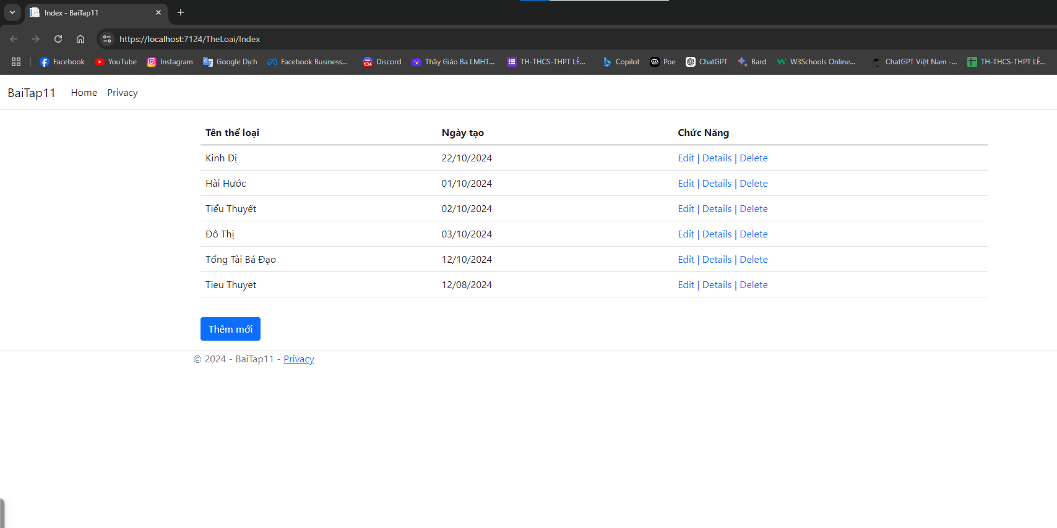

Index theloai:

@{

ViewData["Title"] = "Index";

}

<div class="container">

<table class="table">

<thead>

<tr>

<th>Tên thể loại</th>

<th>Ngày tạo</th>

<th>Chức Năng</th>

</tr>

</thead>

<tbody>

@foreach (var item in ViewBag.TheLoai)

{

<tr>

<td width="30%">@item.Name</td>

<td width="30%">@string.Format("{0:dd/MM/yyyy}", item.DateCreated)</td>

<td width="40%">

<**a** **asp-action**="Edit" **asp-route-id**="@item.Id" class="text-decoration-none">Edit |</**a**>

<**a** **asp-action**="Details" **asp-route-id**="@item.Id" class="text-decoration-none">Details |</**a**>

<**a** **asp-action**="Delete" **asp-route-id**="@item.Id" class="text-decoration-none">Delete</**a**>

</td>

</tr>

}

</tbody>

</table>

<**a** **asp-controller**="TheLoai" **asp-action**="Create" class="btn btn-primary mt-3">Thêm mới</**a**>

</div>

Class TheLoai:

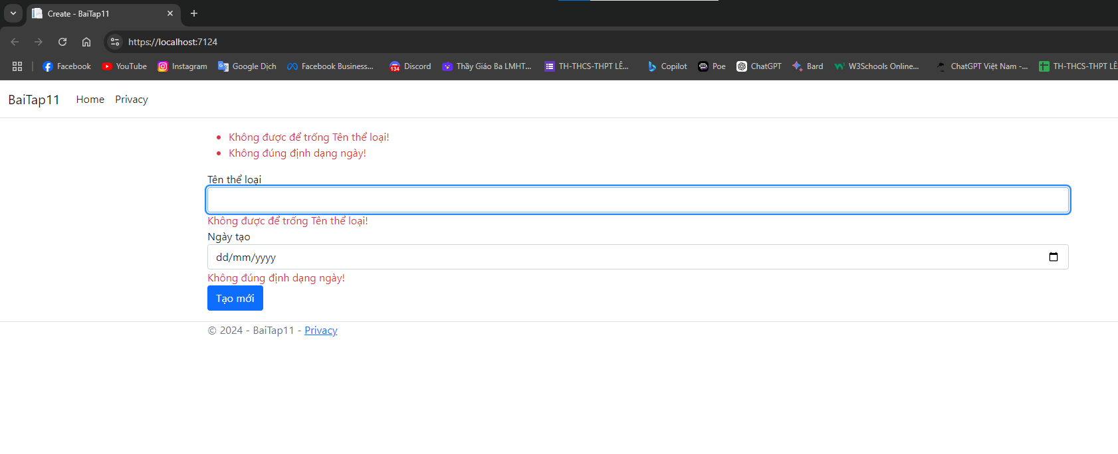

using System.ComponentModel.DataAnnotations;

using System.ComponentModel.DataAnnotations.Schema;

namespace BaiTap11.Models

{

public class TheLoai

{

[Key]

public int Id { get; set; }

[Required(ErrorMessage = "Không được để trống Tên thể loại!")]

[Display(Name = "Thể loại")]

public string Name { get; set; }

[Required(ErrorMessage = "Không đúng định dạng ngày!")]

[Display(Name = "Ngày tạo")]

public DateTime DateCreated { get; set; }=DateTime.Now;

}

}

Index Edit Theloai

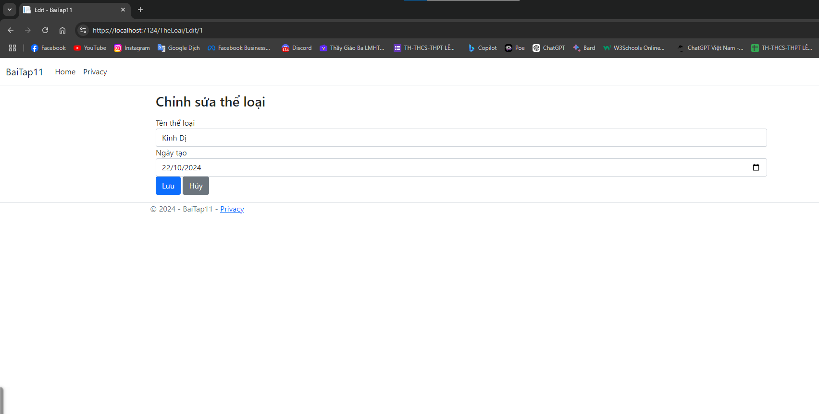

@{

ViewData["Title"] = "Edit";

}

@model TheLoai

<div class="container">

<h3>Chỉnh sửa thể loại</h3>

<**form** method="post" **asp-action**="Edit">

<**div** **asp-validation-summary**="All" class="text-danger"></**div**>

<div class="form-group">

<**label** **asp-for**="Name">Tên thể loại</**label**>

<**input** **asp-for**="Name" **type**="text" class="form-control" />

<**span** **asp-validation-for**="Name" class="text-danger"></**span**>

</div>

<div class="form-group">

<**label** **asp-for**="DateCreated">Ngày tạo</**label**>

<**input** **asp-for**="DateCreated" **type**="date" class="form-control" />

<**span** **asp-validation-for**="DateCreated" class="text-danger"></**span**>

</div>

<button type="submit" class="btn btn-primary">Lưu</button>

<**a** **asp-action**="Index" class="btn btn-secondary">Hủy</**a**>

</**form**>

</div>

Index Detail TheLoai:

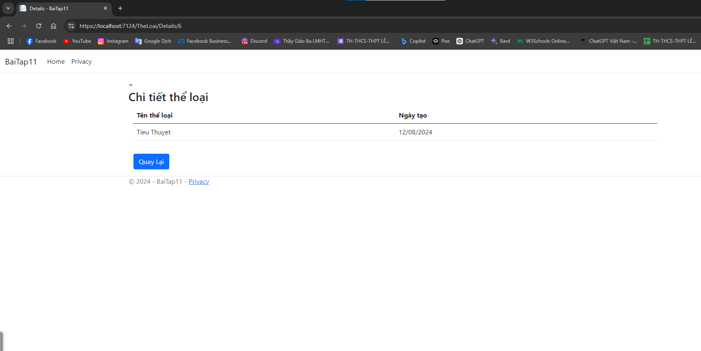=

@{

ViewData["Title"] = "Details";

}

@model TheLoai

<h3>Chi tiết thể loại</h3>

<div class="container">

<table class="table">

<thead>

<tr>

<th>Tên thể loại</th>

<th>Ngày tạo</th>

</tr>

</thead>

<tbody>

<tr>

<td width="30%">@Model.Name</td>

<td width="30%">@string.Format("{0:dd/MM/yyyy}", Model.DateCreated)</td>

</tr>

</tbody>

</table>

<**a** **asp-controller**="TheLoai" **asp-action**="Index" class="btn btn-primary mt-3">Quay Lại</**a**>

</div>

Index Delete TheLoai:

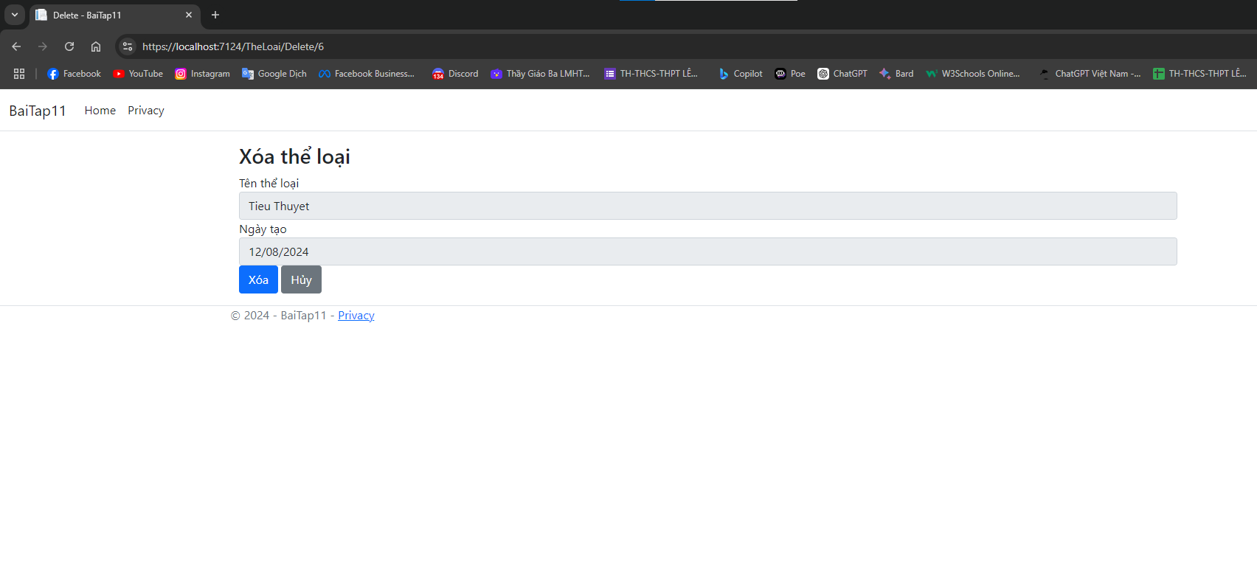

@{

ViewData["Title"] = "Delete";

}

@model TheLoai

<div class="container">

<h3>Xóa thể loại</h3>

<**form** method="post" **asp-action**="DeleteConfirm">

<**input** **asp-for**="Id" **type**="hidden" />

<div class="form-group">

<**label** **asp-for**="Name">Tên thể loại</**label**>

<**input** **asp-for**="Name" **type**="text" disabled class="form-control" />

</div>

<div class="form-group">

<**label** **asp-for**="DateCreated">Ngày tạo</**label**>

<**input** **asp-for**="DateCreated" **type**="date" disabled class="form-control" />

</div>

<button type="submit" class="btn btn-primary">Xóa</button>

<**a** **asp-action**="Index" class="btn btn-secondary">Hủy</**a**>

</**form**>

</div>

Index Create TheLoai:

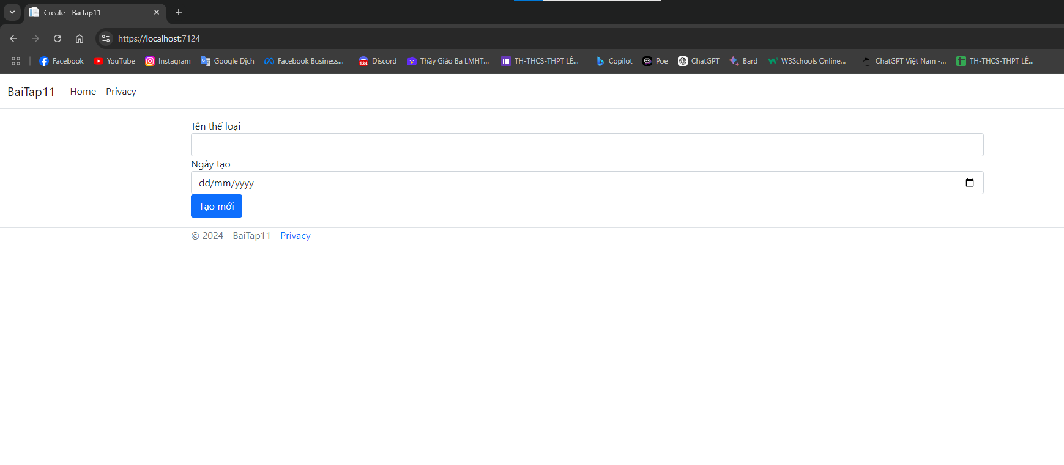

@{

ViewData["Title"] = "Create";

}

@model TheLoai

<**form** method="post">

<**div** **asp-validation-summary**="All" class="text-danger"></**div**>

<div class="form-group">

<**label** **asp-for**="Name">Tên thể loại</**label**>

<**input** **asp-for**="Name" **type**="text" class="form-control" />

<**span** **asp-validation-for**="Name" class="text-danger"></**span**>

</div>

<div class="form-group">

<**label** **asp-for**="DateCreated">Ngày tạo</**label**>

<**input** **asp-for**="DateCreated" **type**="date" class="form-control" />

<**span** **asp-validation-for**="DateCreated" class="text-danger"></**span**>

</div>

<button type="submit" class="btn btn-primary">Tạo mới</button>

</**form**>

@section Scripts {

@{

<**partial** **name**="_ValidationScriptsPartial" />

}

}

SanPham Controller

using BaiTap11.Data;

using BaiTap11.Models;

using Microsoft.AspNetCore.Mvc;

using Microsoft.AspNetCore.Mvc.Rendering;

using Microsoft.CodeAnalysis.CSharp.Syntax;

using Microsoft.EntityFrameworkCore;

using System.Data.Common;

namespace BaiTap11.Controllers

{

public class SanPhamController : Controller

{

private readonly ApplicationDbContext _db;

public SanPhamController(ApplicationDbContext db)

{

_db = db;

}

public IActionResult Index()

{

IEnumerable<SanPham> sanpham = _db.SanPham.Include("TheLoai").ToList();

return View(sanpham);

}

[HttpGet]

public IActionResult Upsert(int id)

{

SanPham sanpham = new SanPham();

IEnumerable<SelectListItem> dstheloai = _db.TheLoai

.Select(sanpham => new SelectListItem

{

Text = sanpham.Name,

Value = sanpham.Id.ToString()

});

ViewBag.DSTheloai = dstheloai;

if (id == 0)

{

return View(sanpham);

}

else

{

sanpham = _db.SanPham.FirstOrDefault(sanpham => sanpham.Id == id);

return View(sanpham);

}

}

[HttpPost]

public IActionResult Upsert(SanPham sanpham)

{

if (ModelState.IsValid)

{

if (sanpham.Id == 0)

{

_db.SanPham.Add(sanpham);

}

else

{

_db.SanPham.Update(sanpham);

}

_db.SaveChanges();

return RedirectToAction("Index");

}

return View();

}

public IActionResult Delete(int id)

{

var sanpham = _db.SanPham.FirstOrDefault(sanpham => sanpham.Id == id);

if (sanpham == null)

{

return NotFound();

}

else

{

_db.SanPham.Remove(sanpham);

_db.SaveChanges();

}

return RedirectToAction("Index");

}

}

}

SanPham Index

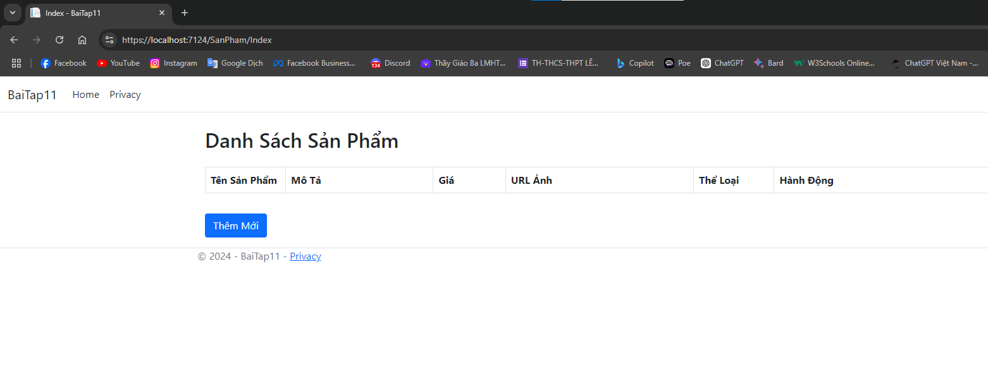

@{

ViewData["Title"] = "Index";

}

@model IEnumerable<SanPham>

<div class="container mt-4">

<h2 class="mb-4">Danh Sách Sản Phẩm</h2>

<div class="table-responsive">

<table class="table table-striped table-bordered">

<thead class="thead-light">

<tr>

<th style="width: 10%;">Tên Sản Phẩm</th>

<th>Mô Tả</th>

<th style="width: 9%;">Giá</th>

<th>URL Ảnh</th>

<th style="width: 10%;">Thể Loại</th>

<th>Hành Động</th>

</tr>

</thead>

<tbody>

@foreach (var item in Model)

{

<tr>

<td>@item.Name</td>

<td>@item.Description</td>

<td>@item.Price.ToString("#,0.000") VNĐ</td>

<td>

<a href="@item.ImageUrl" target="_blank" class="text-decoration-none">@item.ImageUrl</a>

</td>

<td>@item.TheLoai?.Name</td>

<td class="text-nowrap">

<**a** **asp-action**="Upsert" **asp-route-id**="@item.Id" class="btn btn-warning btn-sm me-1">Edit</**a**>

<**a** **asp-action**="Details" **asp-route-id**="@item.Id" class="btn btn-info btn-sm me-1">Detail</**a**>

<a onclick="xoa(@item.Id, $(this))" class="btn btn-danger btn-sm">Delete</a>

</td>

</tr>

}

</tbody>

</table>

</div>

<**a** **asp-controller**="SanPham" **asp-action**="Upsert" class="btn btn-primary mt-3">Thêm Mới</**a**>

</div>

<script>

const xoa = (id, row) => {

$.ajax({

url: `/SanPham/Delete/${id}`,

type: "POST",

})

.done(function (data){

row.closest("tr").remove();

})

}

</script>

SanPham Upsert

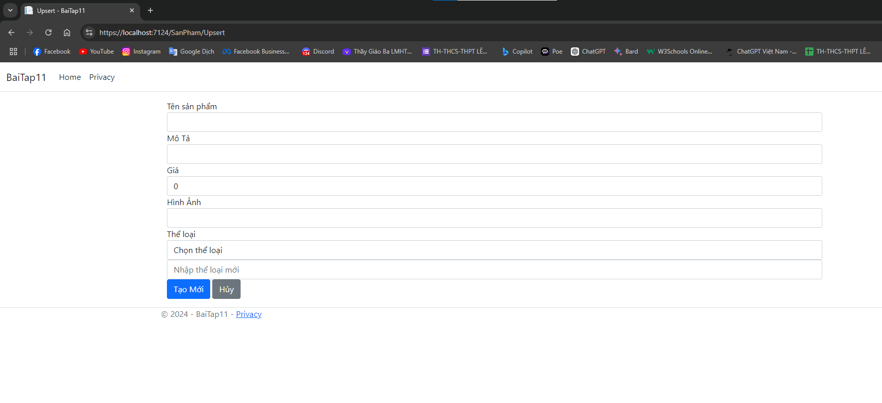

@{

ViewData["Title"] = "Upsert";

}

@model BaiTap11.Models.SanPham

<div class="container">

<**form** method="post" **asp-action**="Upsert">

<div class="form-group">

<**label** **asp-for**="Name">Tên sản phẩm</**label**>

<**input** **asp-for**="Name" **type**="text" class="form-control" />

<**span** **asp-validation-for**="Name" class="text-danger"></**span**>

</div>

<div class="form-group">

<**label** **asp-for**="Description">Mô Tả</**label**>

<**input** **asp-for**="Description" **type**="text" class="form-control" />

<**span** **asp-validation-for**="Description" class="text-danger"></**span**>

</div>

<div class="form-group">

<**label** **asp-for**="Price">Giá</**label**>

<**input** **asp-for**="Price" **type**="number" class="form-control" />

<**span** **asp-validation-for**="Price" class="text-danger"></**span**>

</div>

<div class="form-group">

<**label** **asp-for**="ImageUrl">Hình Ảnh</**label**>

<**input** **asp-for**="ImageUrl" **type**="text" class="form-control" />

<**span** **asp-validation-for**="ImageUrl" class="text-danger"></**span**>

</div>

<div class="form-group">

<**label** **asp-for**="TheLoaiId">Thể loại</**label**>

<**select** **asp-for**="TheLoaiId" **asp-items**="@ViewBag.DSTheloai" class="form-control">

<**option** **value**="">Chọn thể loại</**option**>

</**select**>

<input type="text" id="NewTheLoai" name="NewTheLoai" class="form-control" placeholder="Nhập thể loại mới" />

<**span** **asp-validation-for**="TheLoaiId" class="text-danger"></**span**>

</div>

<button type="submit" class="btn btn-primary">

@(Model.Id == 0 ? "Tạo Mới" : "Cập nhật")

</button>

<**a** **asp-action**="Index" class="btn btn-secondary">Hủy</**a**>

</**form**>

</div>

@section Scripts {

<**partial** **name**="_ValidationScriptsPartial" />

}

Class SanPham :

using Microsoft.AspNetCore.Mvc.ModelBinding.Validation;

using System.ComponentModel.DataAnnotations;

using System.ComponentModel.DataAnnotations.Schema;

namespace BaiTap11.Models

{

public class SanPham

{

[Key]

public int Id { get; set; }

[Required]

public string Name { get; set; }

[Required]

public double Price { get; set; }

public string? Description { get; set; }

public string? ImageUrl { get; set; }

[Required]

public int TheLoaiId { get; set; }

[ForeignKey("TheLoaiId")]

[ValidateNever]

public TheLoai TheLoai { get; set; }

}

}